React.js Component Creation

Name :Hemalatha Reddy Avula

Email :[avulahemalatha1202@gmail.com](mailto:avulahemalatha1202@gmail.com)

Phone no :6305733179

Roll No :20NN1A1201 (IT)

College Name :Vignan’s Nirula Institute of Technology and Science for Women

Source Code:

CARD COMPONENT:

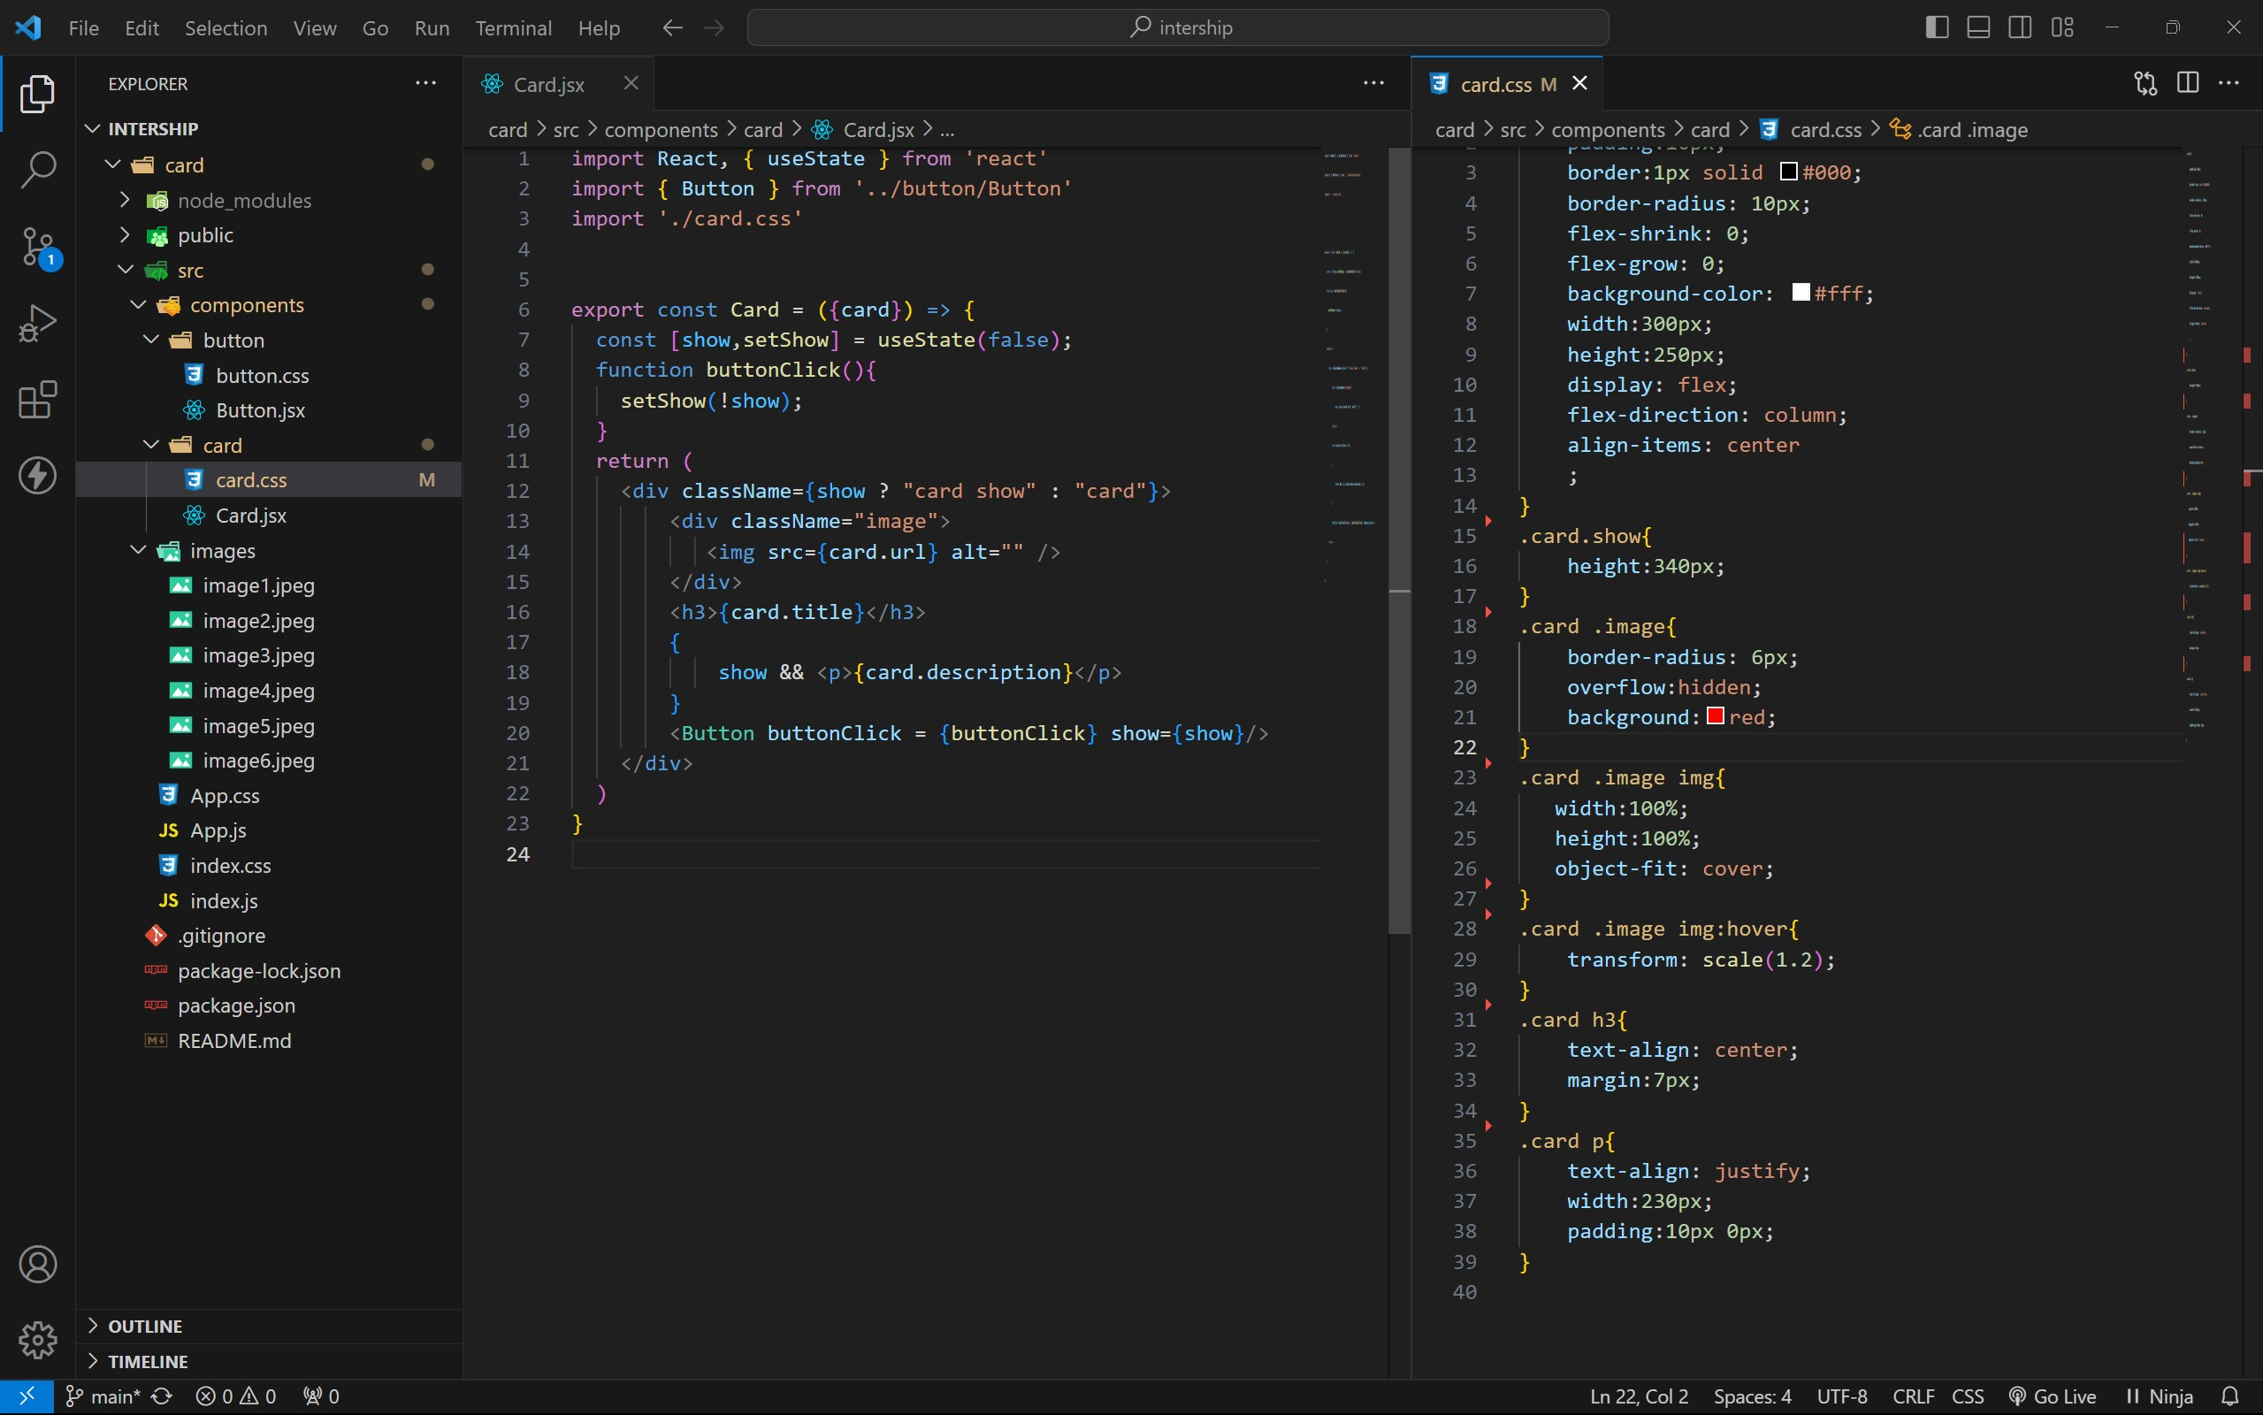

BUTTON COMPONENT:

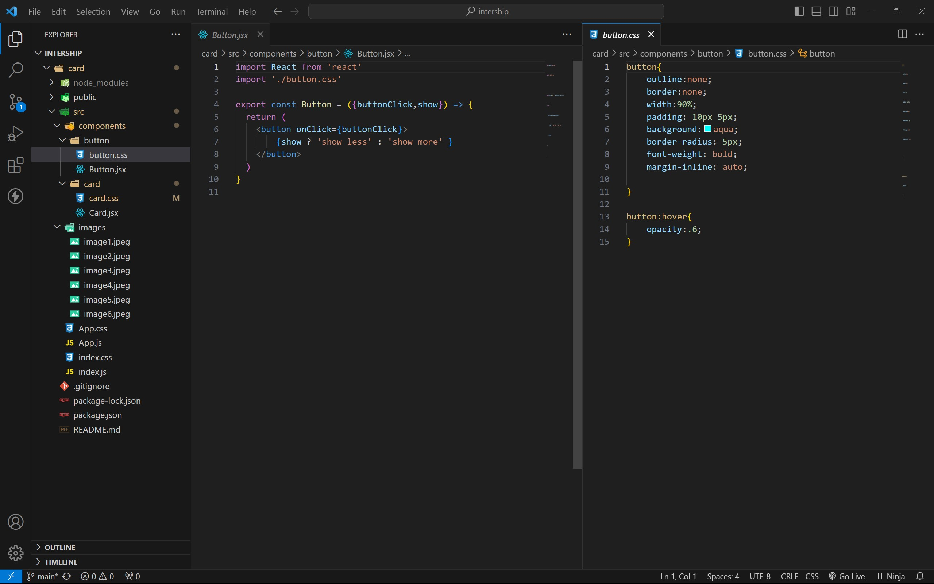

APP COMPONENT:

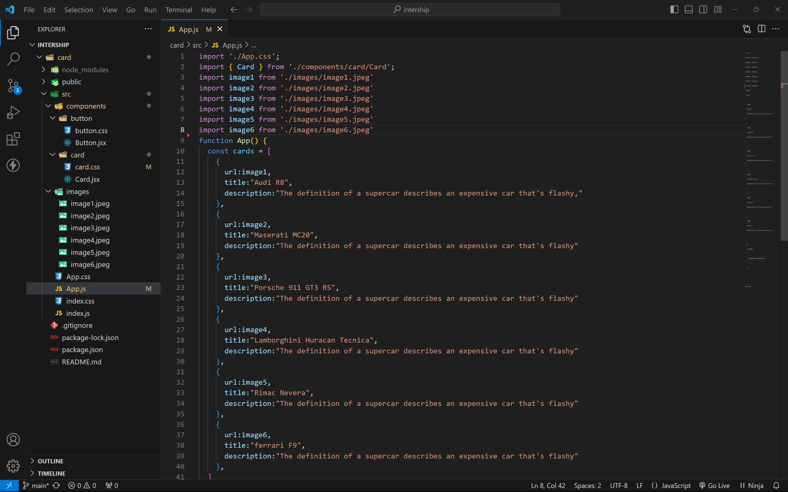

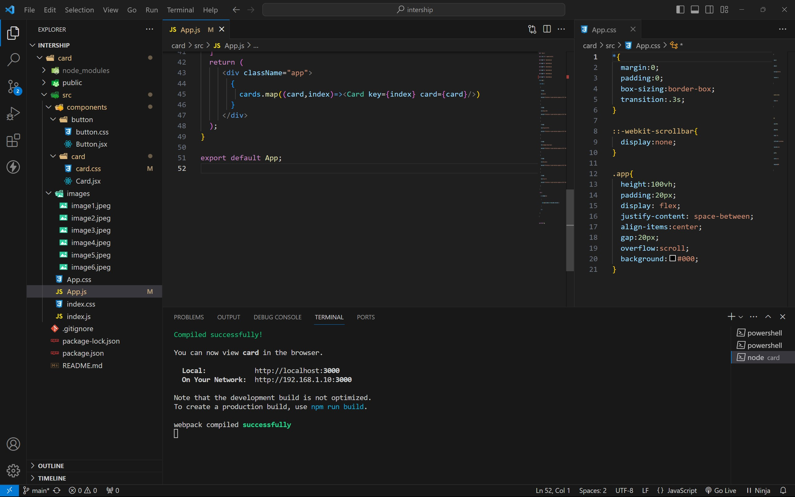

Approach:

1. . Initially taking an array of objects like below

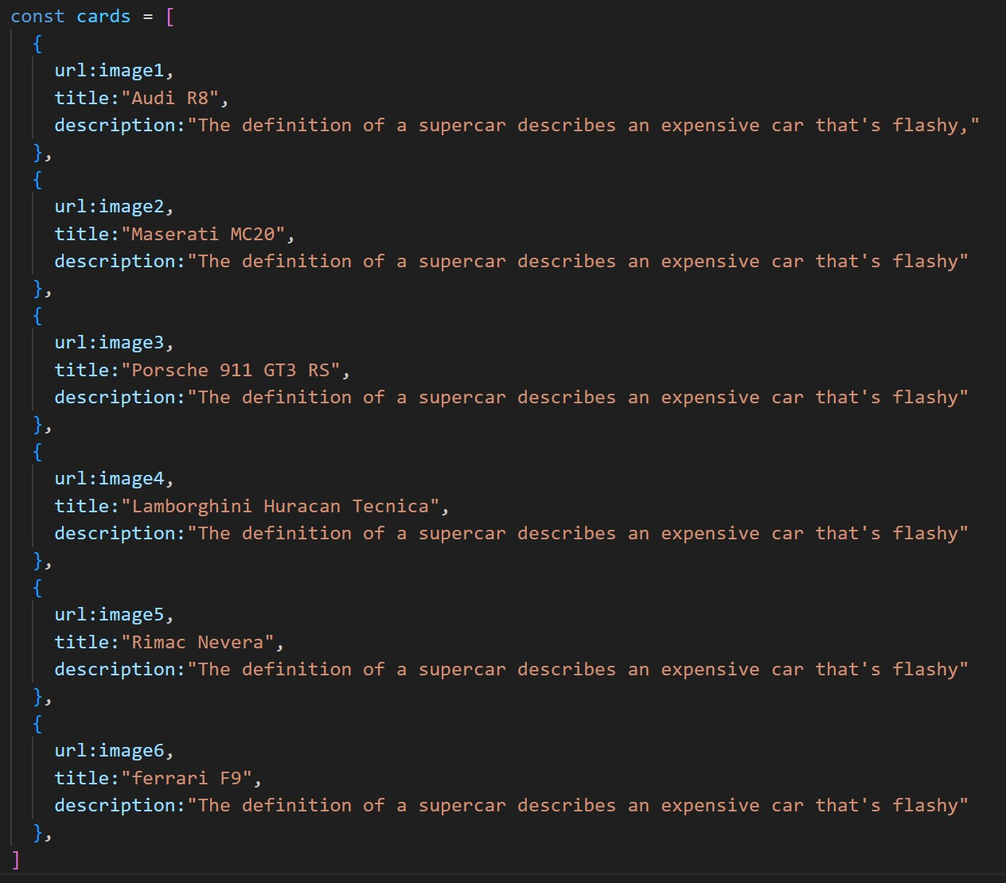

1. . Passing this card array to child (card component) of App component by using props;
2. . Getting data as argument like {card} in card component.
3. . In card component I have used one state [show, setShow] to get extra info as description.
4. . When we click the button then show becomes true by assigning setShow (!show) .

OUTPUT:

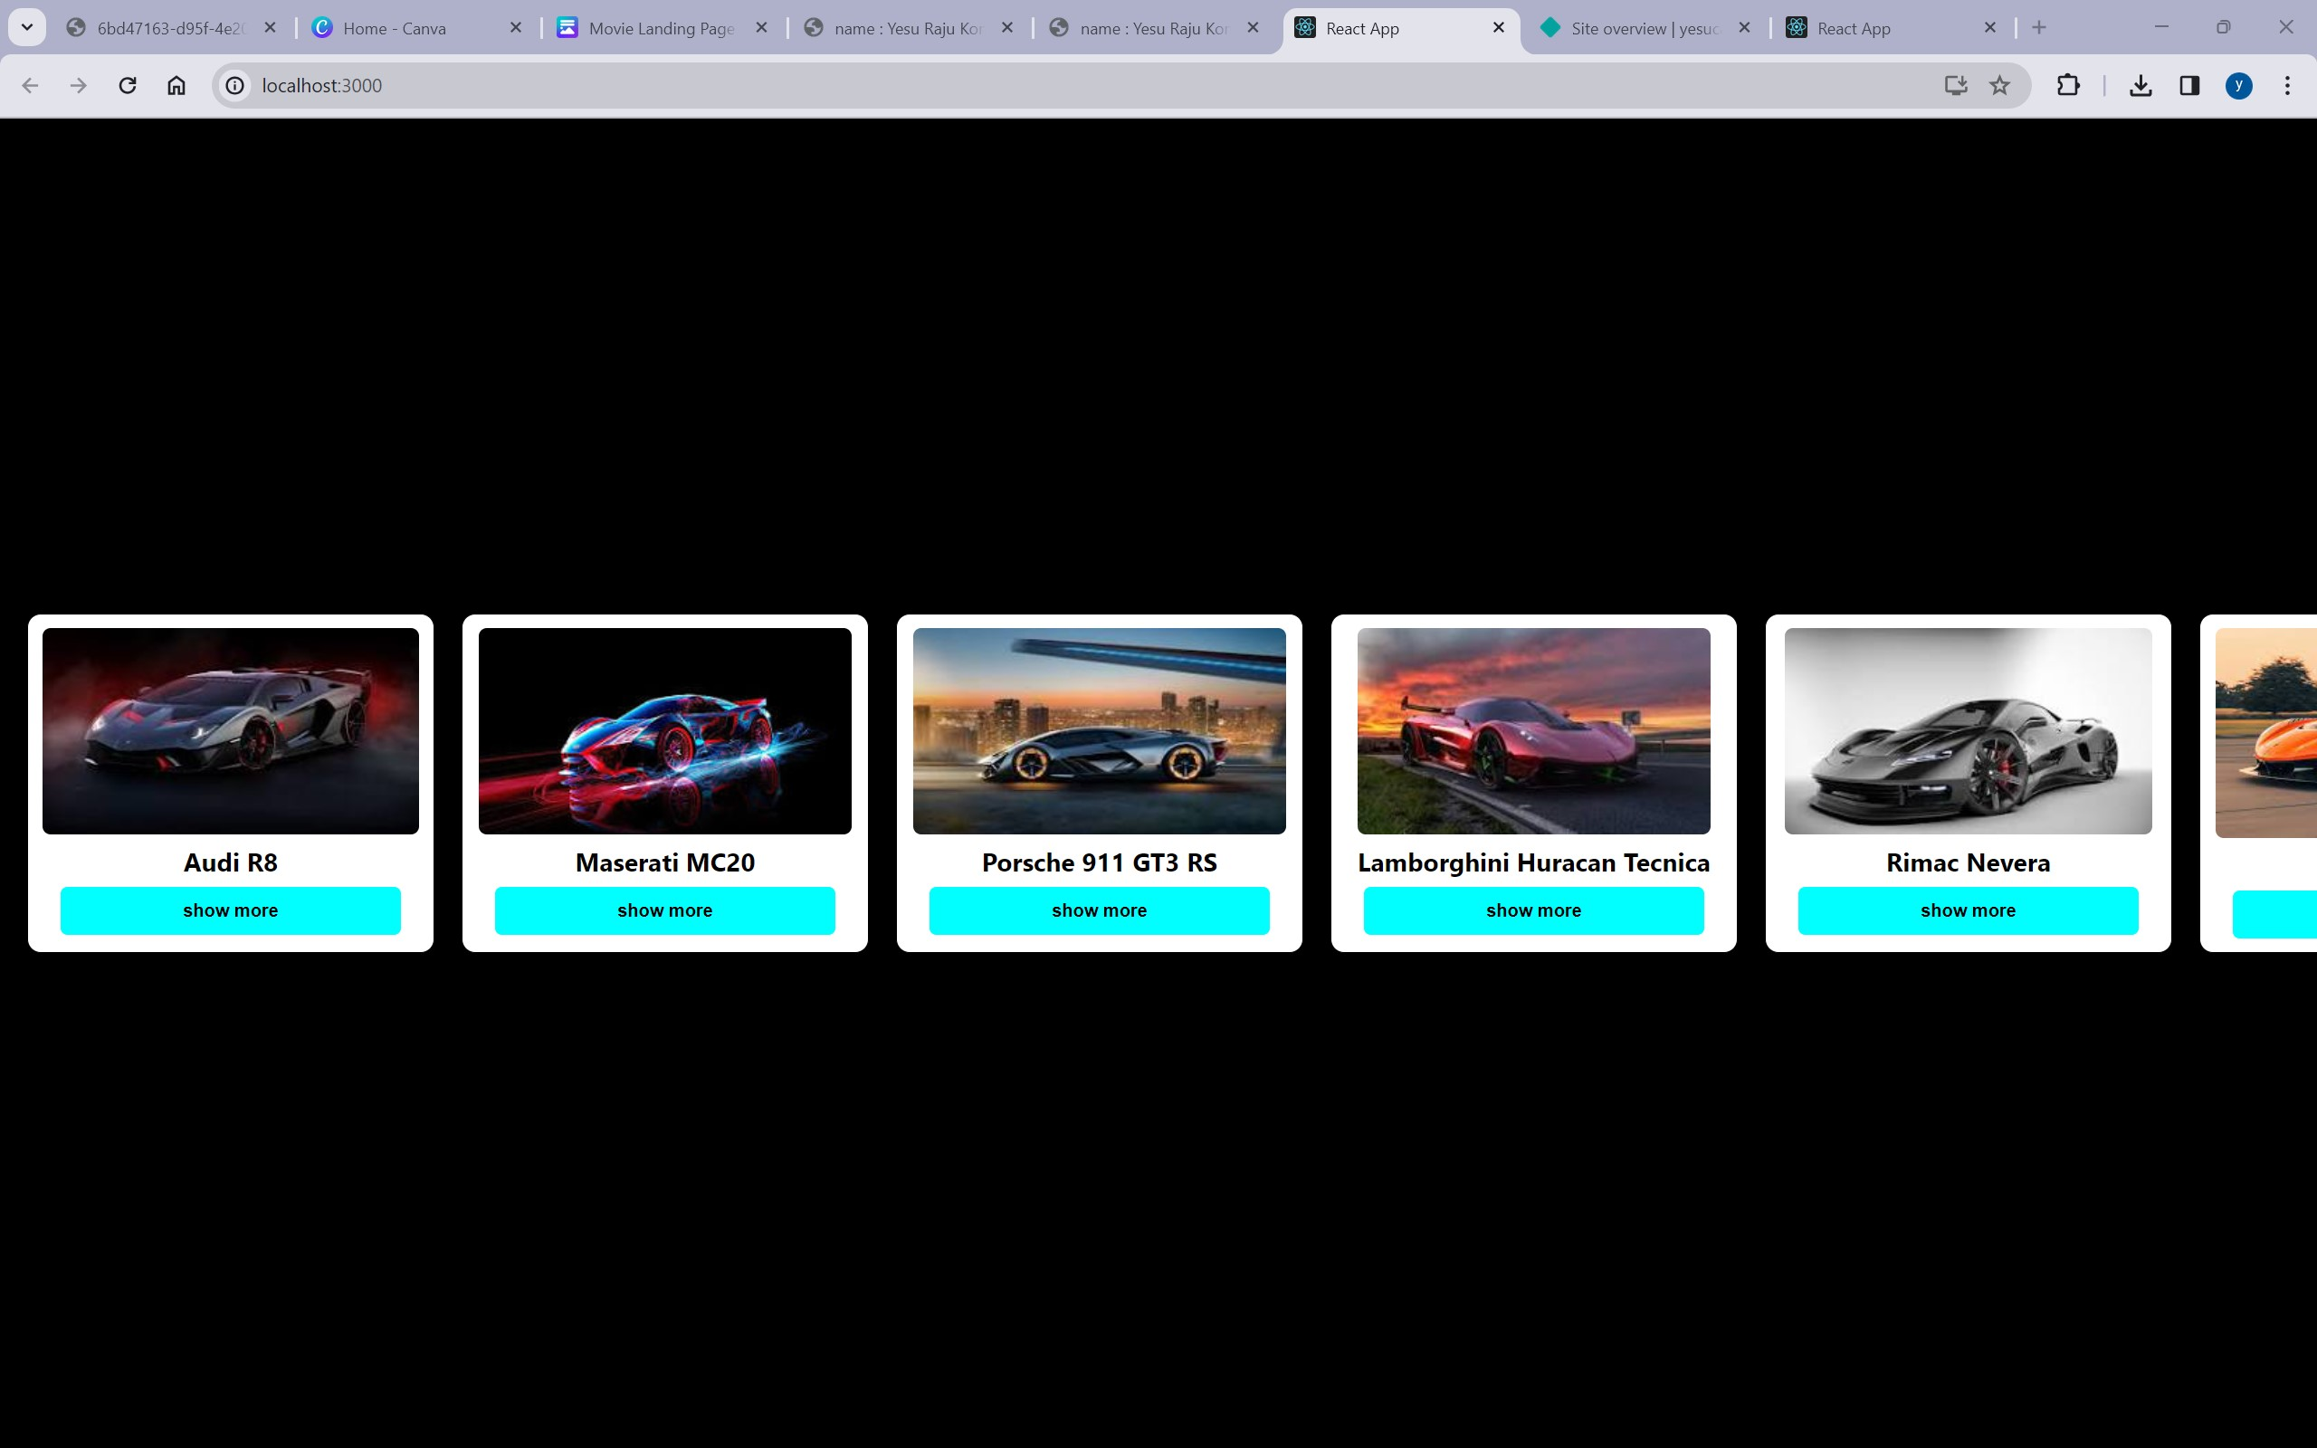

AFTER BUTTON CLICKS:

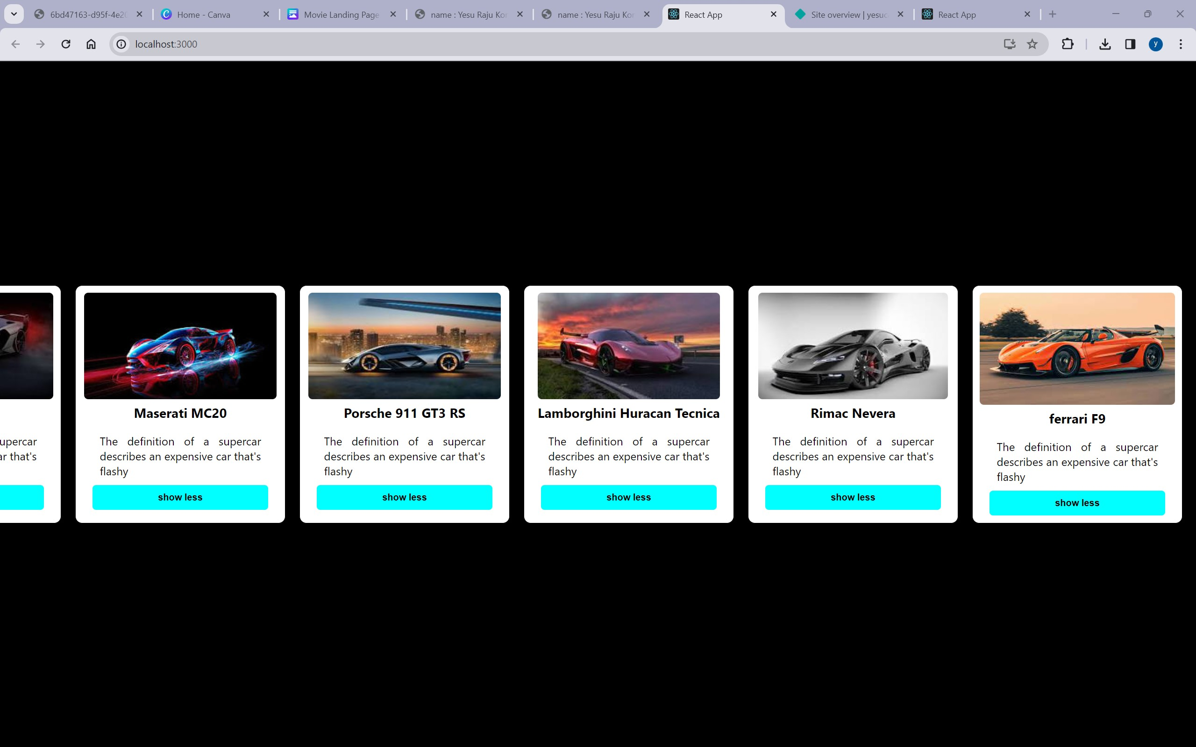

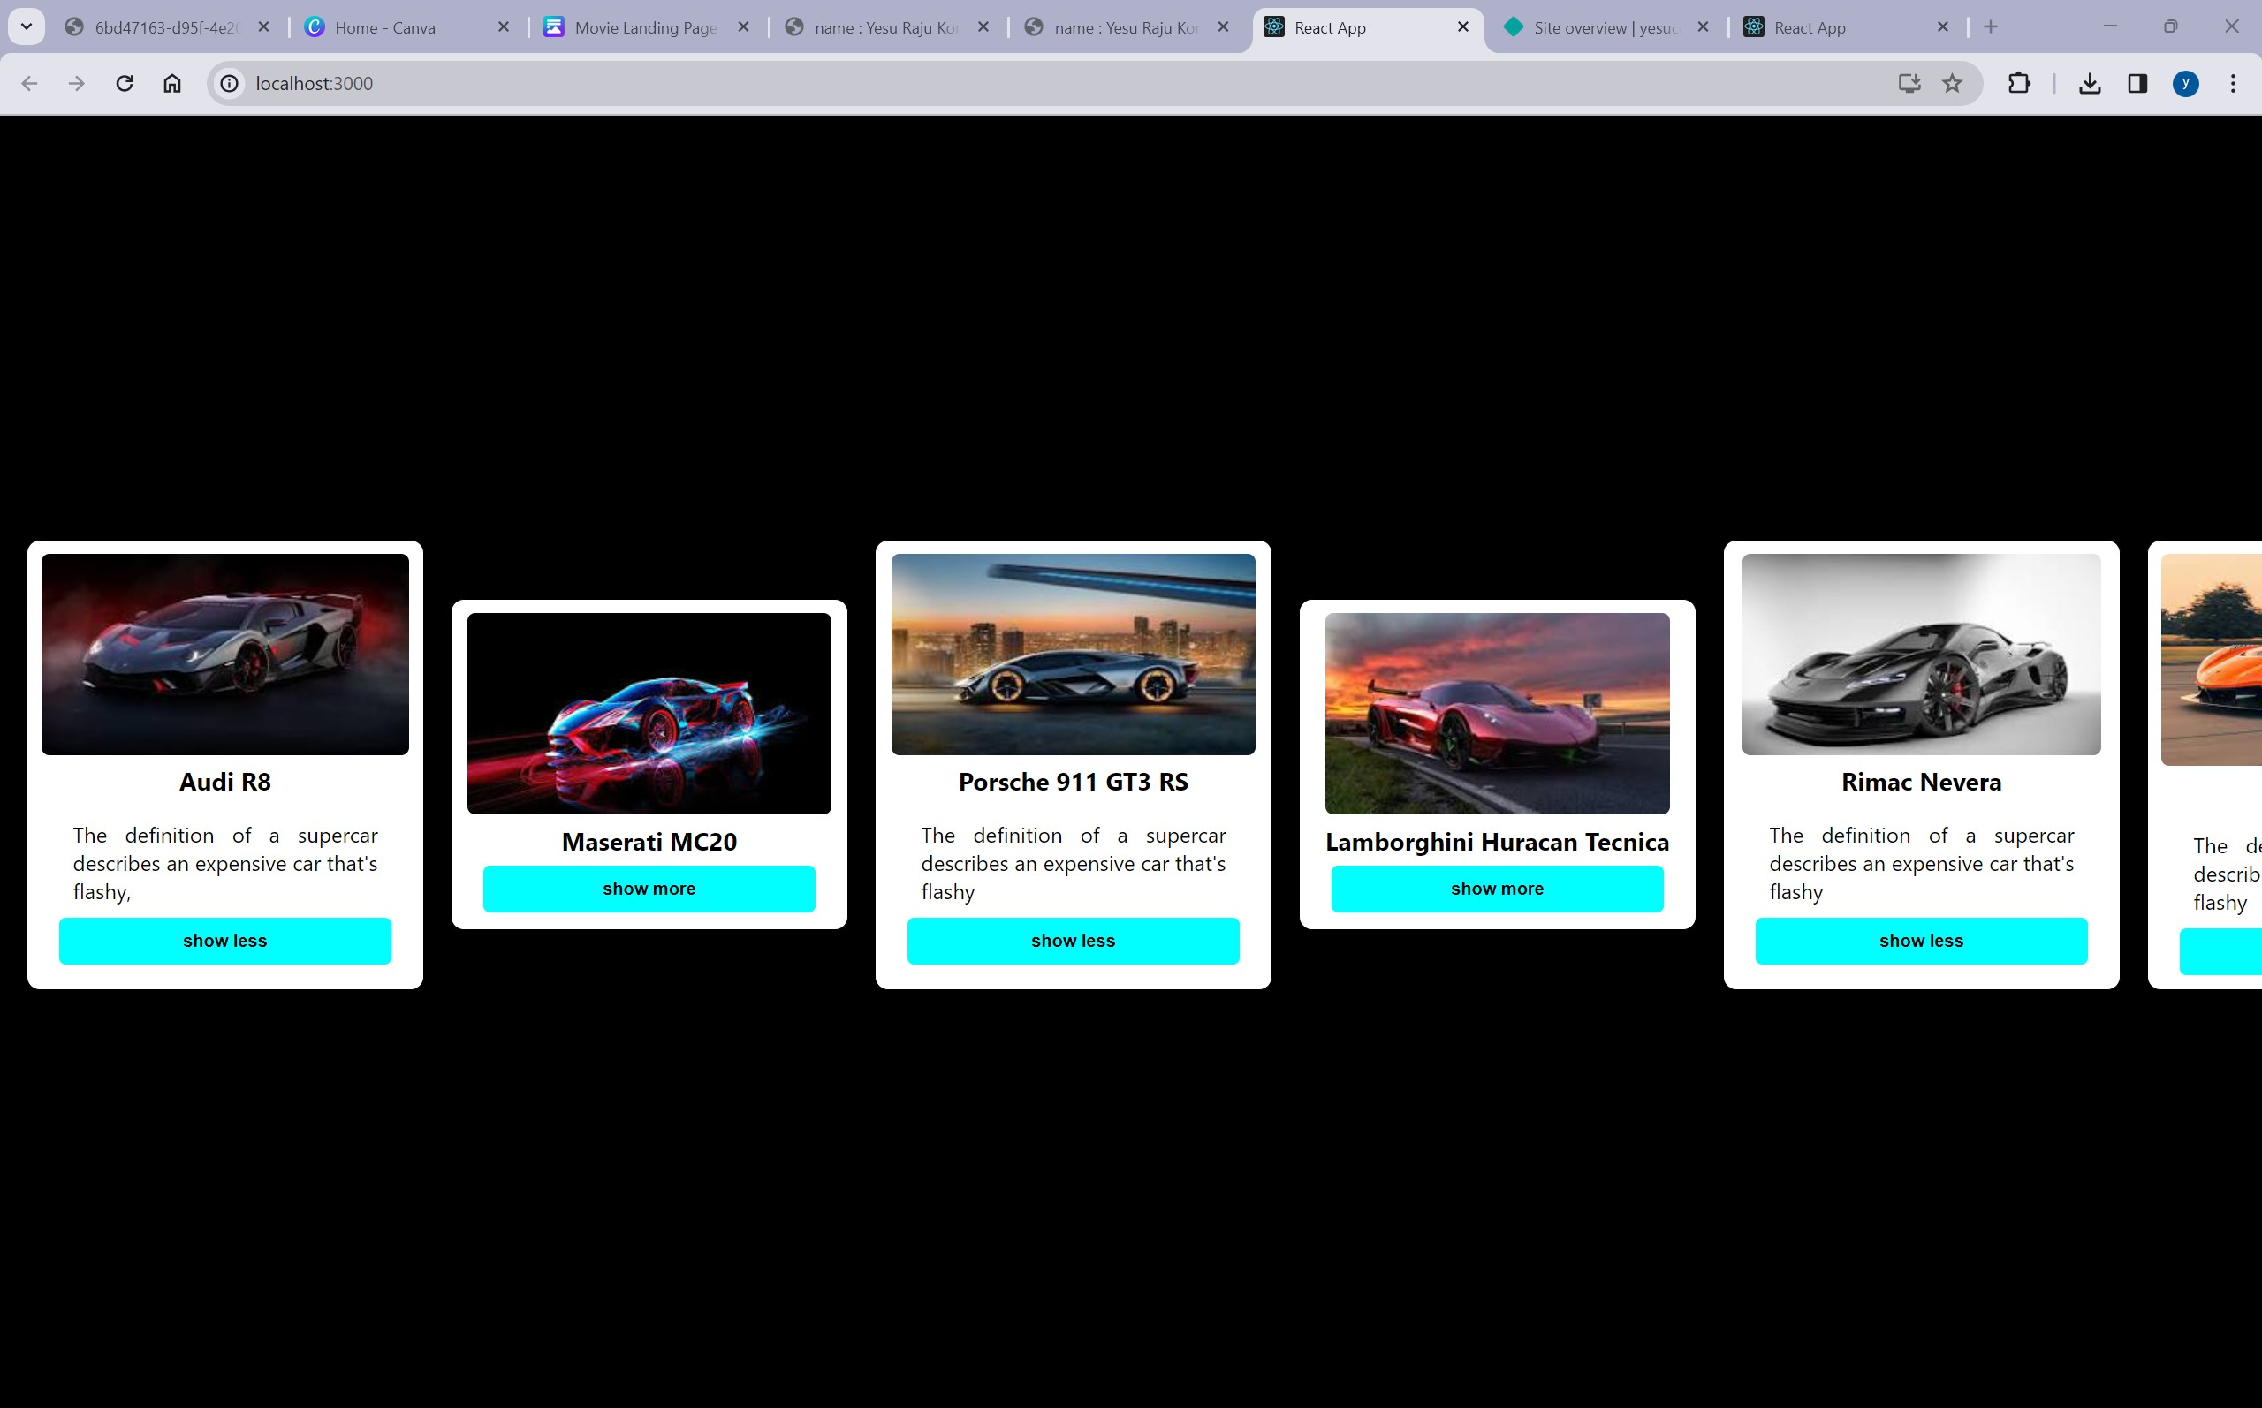

GitHub link :